Title is Centred: All the Initial Letters of Content Words are Capitalised and Twenty-five Words Maximum

Abstract Abstract Abstract Abstract Abstract Abstract Abstract Abstract Abstract Abstract Abstract Abstract Abstract Abstract Abstract Abstract Abstract Abstract Abstract Abstract Abstract Abstract Abstract Abstract Abstract Abstract.

Keywords: keyword; keyword; keyword; keyword; keyword

1. Heading
Main Body Main Body Main Body Main Body Main Body Main Body Main Body Main Body Main Body Main Body Main Body Main Body Main Body Main Body Main Body Main Body.

(1) Example, example
(2) Example, example

Main Body Main Body Main Body Main Body Main Body Main Body Main Body Main Body Main Body Main Body Main Body Main Body Main Body Main Body Main Body Main Body.

1.1. Subheading: Remember to Capitalise the Initial Letters of Content Words
Main Body Main Body Main Body Main Body Main Body Main Body Main Body Main Body Main Body Main Body Main Body Main Body Main Body Main Body Main Body Main Body.

Table 1. Tables are numbered at all times

Table 1 | Table 1
Table 1 Table 1 | Table 1 Table
Table 1 | Table 1

1.1.1. Subheading: Remember to Capitalise the Initial Letters of Content Words
Main Body Main Body Main Body Main Body Main Body Main Body Main Body Main Body Main Body Main Body Main Body Main Body Main Body Main Body Main Body Main Body.

Figure 1. Figures are numbered at all times

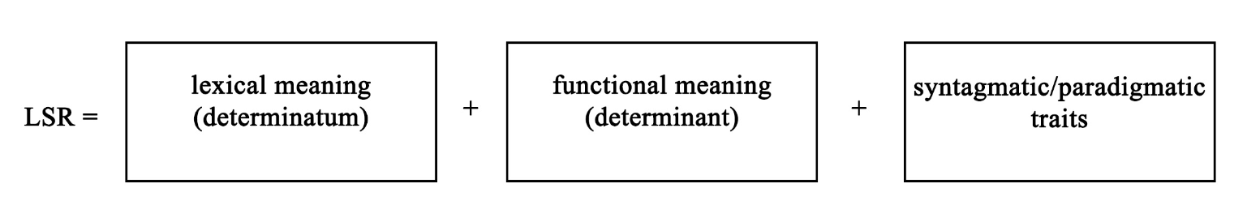

Works Cited
Aronoff, Mark. 1976. Word Formation in Generative Grammar. Cambridge, MA: MIT Press.
Audring, Jenny and Francesca Macini, eds. 2016. The Oxford Handbook of Morphological Theory. Oxford: Oxford UP.

Appendix 1

Footnote, footnote, footnote.

