Title centred, in 16 pt with all Content Words Capitalised

Abstract:
(12 pt, justified, single paragraph, 200-300 words)
The abstract must include objectives, methodology, results, and conclusions of the study. It should present the topic and findings clearly, without citations or subsections. Narrative abstracts are recommended, between 200 and 300 words.

Keywords: (12 pt; minimum 6 keywords; there is no maximum number; separated by semicolons; use terms from title and common terms in the field)
Example: keyword; keyword; keyword; keyword; keyword; keyword

(Page break)

1. First-level heading bold, a single space (not a tab) after number. Remember to Capitalise the Initial Letters of Content Words
Main body 12 pt, 0.5 line spacing, left- and right- justified, Main body, main body, main body, main body, main body, main body, main body, main body, main body, main body, main body. References are as suggested by Author (1997a, 16) and dates are formatted without a comma when only the month and year are used (June 25) but with a comma if a year is used (July 12, 1998). Decades are preferably expressed in numerals (the 1930s). “Quotations of up to about 75 words should be run into the surrounding text,” (Author 1997a, 16) whereas anything longer should be set as a block quote:

Block quotations at 11 pt, 0.5 line spacing, left- and right-justified, whole paragraph indented 0.5. Block quotation, block quotation, block quotation, block quotation, block quotation, block quotation, block quotation, block quotation, block quotation, block quotation, block quotation, block quotation, block quotation, block quotation, block quotation. (Author 1995, 38)

The use of dashes is recommended, rather than parentheses, and the em-dash—the long dash—is preferred, without a space before and after it. Main body, main body, main body, main body, main body, main body, main body, main body, main body, main body, main body, main body.

1.1. Subheading (bold italic): Remember to Capitalise the Initial Letters of Content Words
Main body, main body, main body, main body, main body, main body, main body, main body, main body, main body, main body, main body, main body:

(1) Examples numbered and indented 0.5
(2) Example, example

Main body, main body, main body, main body, main body, main body, main body, main body, main body, main body, main body, main body, main body, main body, main body.

Table 1. Title (Tables are numbered at all times)

Table 1 | Table 1
Table 1 Table 1 | Table 1 Table
Table 1 | Table 1

Source: Author’s own

1.1.1. Subheading (italic): Remember to Capitalise the Initial Letters of Content Words
Main body, main body, main body, main body, main body, main body, main body, main body, main body, main body, main body, main body, main body, main body, main body.

Figure 1.Title (Figures are numbered at all times)

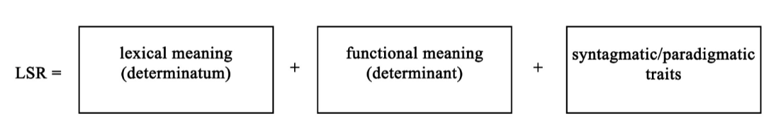
Source: The British Library

References
(Follows Chicago Manual of Style, latest edition; full author names; complete page ranges)

If the publication has a DOI (Digital Object Identifier), it must appear at the end of the entry as a secure URL link, without prefixes or a final full stop. The DOI replaces any web address in the reference.
CrossRef’s Simple Text Query can be used for checking DOIs included in a reference list.

[Books and studies]
Bauer, Laurie, Rochelle Lieber and Ingo Plag. 2015. The Oxford Reference Guide to English Morphology. Oxford: Oxford UP.
Chomsky, Noam. 1986. Knowledge of Language: Its nature, Origin, and Use. New York: Praeger.
Huggins, Mike and James Anthony Mangan. 2004a. “Prologue: All Mere Complexities.” In Huggins and Mangan 2004b, ix-xx.
[Edited books: Both chapter books and the edited volume should be cited]
Gippert, Jost, Nikolaus P. Himmelmann and Ulrike Mosel, eds. 2006. Essentials of language documentation (Trends in Linguistics, Studies and Monographs 178). Berlin and New York: Mouton de Gruyter.
Horton, Dave, Paul Rosen and Peter Cox, eds. 2007. Cycling and Society. Aldershot: Ashgate.
Simpson, Clare S. 2007. “Capitalising on Curiosity: Women’s Professional Cycle Racing in the Late-Nineteenth Century.” In Horton, Rosen and Cox 2007, 47-66.

[Conference proceedings]
Przedlacka, Joanna, John Maidment and Michael Ashby, eds. 2013. Proceedings of PTLC 2013. Papers from the Phonetics Teaching and Learning Conference. London: PTLC.

[Translations]
Holquist, Michael. 1984. Prologue to Rabelais and his World, by Mikhail Bakhtin, xiii-xxiii. Translated by Hélène Iswolsky. Bloomington: Indiana UP.

[Reprints]
Booij, Geert. (2005) 2007. The Grammar of Words. Oxford: Oxford UP.

[Articles]
Bergh, G., & Ohlander, S. 2019. “A Hundred Years of Football English: A Dictionary Study on the Relationship of a Special Language to General Language”. Revista Alicantina de Estudios Ingleses / Alicante Journal of English Studies 32: 15-43. https://doi.org/10.14198/raei.2019.32.02
Kastovsky, Dieter. 1986. “The Problem of Productivity in Word-formation.” Linguistics 24: 585-600.

[Newspaper and website articles]
When quoting online texts, the URL and date of access should be included.
Plath, Sylvia. 1965. “The Colossus.” Poetry Foundation. https://www.poetryfoundation.org/poems/89119/the-colossus [Accessed online on Juny 4, 2020]

[Unpublished dissertations]
Baker, Will. 2009. “Intercultural Awareness and Intercultural Communication through English: An Investigation of Thai English Language Users in Higher Education.” PhD diss., University of Southampton.

[Lectures/paper presented at conferences]
Edwards, Paul. “Girl Reading: Wyndham Lewis and Iris Barry.” Lecture given at the Leeds Art Fund, Leeds, March 2016.

